| * Chapter 10: Why Bitcoin?   + 10.0 Intro - Why Bitcoin?     - **Activity** - What could a Bitcoin future look like?   + 10.1 What are Central Bank Digital Currencies (CBDCs), and who controls them?   + 10.2 The Philosophy of Bitcoin     - **Activity** - Class Discussion - Do you have the right to control your own money?   + 10.3 The Benefits of Bitcoin   + 10.4 An Empowered Future     - **Activity -** Class Discussion - How did your perspective change? |
| --- |

# 

# 

—-------------------------------- Notes only - Below not in 2024 workbook —---------------------------

* + ***Notes to designer:***
    - **Activity** in chapter 10.0 Introduction was the QR code on page 160 - watch the video
    - **Images: Satoshi image in Chapter 10 image folder:** [**https://drive.google.com/drive/folders/1AxrE6YrZuA5Pr_NprwfFsflikNxEY7Fl?usp=drive_link**](https://drive.google.com/drive/folders/1AxrE6YrZuA5Pr_NprwfFsflikNxEY7Fl?usp=drive_link)
    - **Activity - Final Class Discussion - Please insert the page number of the questions section in** chapter 1 where we asked the students to write their answers to the 5 questions

—---------------------------- Notes only - Above not in 2024 workbook —---------------------------------

# Chapter 10: Why Bitcoin?

"Bitcoin is more than a currency; it's a revolution restoring power to the people,

offering a taste of peace and freedom in a world hungry for empowerment."

My First Bitcoin

In this concluding chapter, we'll summarize the lessons learned throughout our journey, ask and discuss a few important questions, and explore the future of Bitcoin.

Bitcoin is not just a technology, it’s a type of network which powers a new form of money whose supply cannot be changed by any single party. **Humanity has never had a form of money with a fixed supply and no centralized control**. If widely adopted, Bitcoin is a tool that unlocks a movement for positive change that can transform the lives of people all over the world. It represents a peaceful revolution towards collective freedom and equity, opening up new opportunities for humanity by creating a shared global monetary system.  
  
As a decentralized global system, Bitcoin enables greater financial freedom, shifting power from the few to the many. It provides a secure, censorship-resistant platform for storing and transferring value, empowering individuals to take control of their wealth and protect their purchasing power. This is especially important in today’s uncertain economic climate, where the traditional financial system is facing unprecedented challenges.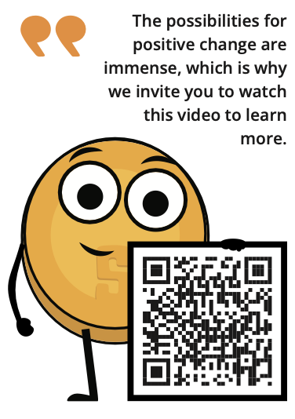

**Activity** - Watch the video [[QR code](https://www.youtube.com/watch?v=3Rnqst5qCgA&ab_channel=SwanBitcoin)]

Next, we’ll look at another form of digital currency called a Central Bank Digital Currency (CBDC), and evaluate how they are similar and different to Bitcoin.

## 10.1 What are Central Bank Digital Currencies (CBDCs), and who controls them?

Central Bank Digital Currencies, or CBDCs, are digital versions of regular fiat money. CBDCs follow the same rules as regular fiat money where a central authority, like the government, can create more supply and thereby is capable of reducing people’s purchasing power. However, CBDCs also grant governments new and potent tools to control how that money is used by people around the world.

According to the Human Rights Foundation (HRF) research, 119 out of 193 governments worldwide are looking into, testing, or using CBDCs.

| [RESOURCE BOX]  You can check if your country is trying CBDCs on the Human Rights Foundation’s CBDC tracker at <https://cbdctracker.hrf.org/home> or <https://cbdctracker.org/>  [ALSO INSERT A PICTURE HERE OF “THE CBDC TRACKER WORLD MAP”] |
| --- |

So, what makes CBDCs different from regular fiat money besides being digital?

It's a crucial thing to understand, that unlike regular fiat money in the form of paper or coins, CBDCs let the government digitally watch and control every transaction globally. This means the government can stop certain transactions or even freeze your whole account if they don't like you or how you're using your money.

For example, imagine you want to send money to a family member in a country that needs help, but your local government rejects your transaction because they don’t agree with that country's leaders. Or picture going to the store to buy something you like, but you can't because you expressed your opinion on social media.

CBDCs give governments unlimited power to control how money is used around the world, limiting individuals' ability to spend money based on their own choices. Some even argue that CBDC’s would enable powerful governments to centrally enforce tyrannical policies on a global scale—at the flick of a switch—without the need for human enforcement agents.

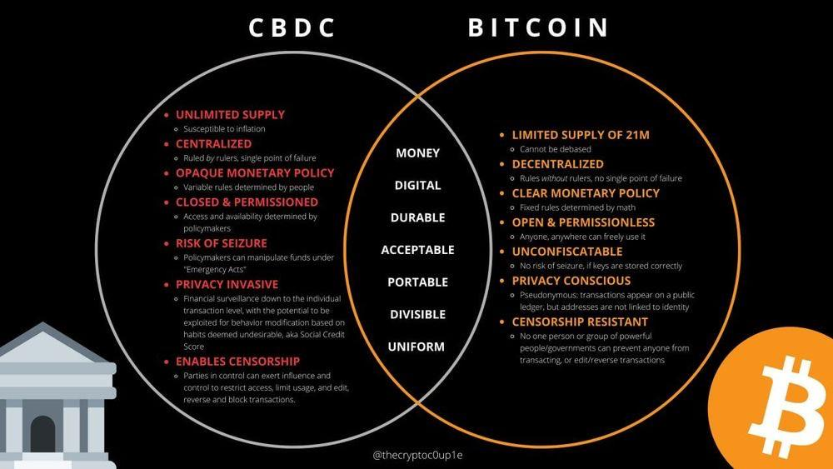

Both CBDCs and Bitcoin are digital, but beyond this commonality, they represent very different forms of money with distinct philosophies, leading to varied outcomes for humanity.

## 10.2 The Philosophy of Bitcoin

In chapters 6 and 9, we found out that individuals who run a Node help keep Bitcoin's rules safe. This is a big deal because, for the first time ever, people like us can be part of a team that makes sure the rules of our monetary system are protected. These rules include the fact that there's only a limited amount of money, and no one single party can change these rules. It's a special chance for regular people to help keep our money secure and reliable.

Bitcoin's philosophy is about empowerment, freedom, financial independence, critical thinking, and the concept that we should all have a say in the rules of the system we choose for ourselves. Unlike the fiat system controlled by powerful central parties, Bitcoin works on a network where no single party has all the control. This means, unlike other types of money, like CBDCs, nobody can take your property from you or stop you from spending your money the way you want.

In the fiat world, having more wealth directly translates to having more influence and control. Contrastingly, Bitcoin operates in a way that's all about power to the people. It's like a team effort where everyone, no matter how much money they have, plays a crucial role in the system. Imagine it as a collective force, where your financial size doesn't automatically mean you control everything. Bitcoin is built on unchangeable rules, and, in this harmony, it's as if humanity itself is in control of the system. It's not a few big shots calling the shots; it's all of us working together, much like a resilient community, guiding the course of Bitcoin without any single authority telling it what to do.

While in the fiat system the powerful dictate the rules, in the Bitcoin ecosystem, it's the collective strength of individuals that sustains the network. No single entity, regardless of wealth, can dictate the path of the Bitcoin ecosystem. It's an inversion of the traditional power dynamic, where the resilience of the system lies not in the hands of the few, but in the collective power of every participant.

The main idea is to create a safe, clear, and fair system where everyone can access global money equally.

**Activity** - Class Discussion - Do you have the right to control your own money?

1. Is money a human necessity and a human right? And why?
2. If you can’t spend your money how you want, send it to who you want, or take your money with you to a new country, is it really yours? And why?
3. Why did barter stop being used? What is the problem with the double coincidence of wants?
4. What historical event was the most impactful for you? Why is it important to understand the Nixon shock and its relevance for everyone today?
5. How is money with a fixed supply different from traditional fiat currencies?
6. When was Bitcoin created, by whom, for what purpose, and how does this purpose define the concept of a decentralized system?
7. What is the difference between a custodial and a non-custodial wallet? What was your favorite wallet?
8. What do you understand about the Lightning Network? What type of transactions would you use it for?
9. Why does running your own Node support the network?
10. How does having control over your own money empower you in your daily life and future planning?
11. In what ways can financial freedom enhance your ability to contribute positively to your community or society?

## 10.3 The Benefits of Bitcoin

”Hyperbitcoinization” is a theoretical future where Bitcoin becomes the dominant global monetary system. This would mean that bitcoin would be used by everyone, everywhere, and for everything—from buying coffee to paying bills and even to buy a house.

The growing interest in Bitcoin by individuals, businesses, countries, and governments highlights the potential impact of its widespread adoption on the economy and society. Here are some of the benefits of a hyper-bitcoinized world:

1. A Self-Sovereign Future: A self-sovereign future is one where individuals worldwide have full control over their own digital identity and assets. This could lead to greater financial inclusion, freedom, privacy, security, and thereby contributing to heightened human flourishing, abundance, and overall happiness.
2. A Reliable Store of Value: Bitcoin’s digital scarcity makes it a reliable store of value, which could encourage more people to use it as a means of saving for the future.
3. Changes in Monetary Policy: If Bitcoin were to become widely adopted, it could undo the ability of governments to control the money supply through traditional monetary policy tools. Mass adoption of Bitcoin would potentially increase people’s purchasing power and encourage society to move towards low-time preference activities.
4. Enhanced Transparency and Traceability: The tamper-proof and immutable record of all transactions on the blockchain could increase transparency and accountability in various industries and sectors. Currently, powerful entities have the ability to move trillions of dollars around the world without clear visibility into where these funds go or how they are utilized. By providing an open and verifiable record of financial transactions, Bitcoin could ensure that the movement of capital becomes more accountable and accessible to the public.
5. A Revolution in the Remittance Market: The remittance market involves the transfer of funds from one party to another, often across international borders. Despite declining costs, remittances remain relatively expensive compared to domestic bank transfers, especially for smaller amounts. The Lightning Network offers fast and low-cost transactions, making it well-suited for the remittance market and addressing the high costs and other challenges associated with remittances, such as slow settlement times and restrictions on business hours.
6. Abundant Energy: When there's a lot of affordable energy, societies do well, and many industries and communities can meet the increasing need for power in homes, businesses, and new technologies. Bitcoin mining incentivizes miners to use surplus energy which would usually go to waste from sustainable energy sources like solar, wind, and hydroelectric power. Bitcoin Miners use this surplus energy to create new bitcoin through mining activities, secure the network, and offer excess energy they create back to the energy grid society uses when it is needed.

## 10.4 An Empowered Future

Bitcoin is money.

Money helps people communicate which activities, goods and services are most important within society. As we have seen in this course, when money is controlled by centralized authorities, it will be manipulated.

One of the mistakes humanity keeps repeating throughout history is manipulating money, which then negatively affects individuals, families, businesses, governments, and ultimately global human prosperity.

By taking the control of money out of the hands of centralized parties, and instead using money with a fixed supply which no single party can change, we create a different world. *One where we don’t have to trust that man will do the right thing, but rather one in which man is unable to do the wrong thing.*

*This is a fundamentally different world.*

And you, dear student, can be a part of creating this world. By using Bitcoin, running your own node, and helping your fellow man learn more about the future of money, you are voting for a different world.

**Activity** - Final Class Discussion - How did your perspective change?   
  
Please answer the 5 questions below:

Why do we need money?

_______________________________________________________________________

_______________________________________________________________________

What is money?

_______________________________________________________________________

_______________________________________________________________________

Who controls money?

_______________________________________________________________________

_______________________________________________________________________

*What gives money its “value”?*

_______________________________________________________________________

_______________________________________________________________________

What question do you have about money? Write down your question here to share with the class.

_______________________________________________________________________

_______________________________________________________________________

1. Go back to the first activity in chapter 1, and compare your new answers to your old answers.
2. Compare and discuss the original answers and questions. Did something change?
3. Ask yourself this final question: What is my next step? And how can I use this new knowledge to empower myself?



| *“If you’re ready to take the next step, check out the next additional resources section, where we have selected the best resources for further learning and success.”* |
| --- |